**ASSIGNMENT 1**

**Aim**

Design the front pages of a website using HTML and CSS properties.

**Hardware Requirements**

The hardware requirements for designing a website using HTML and CSS properties will vary depending on the complexity of the website. However, some basic hardware requirements include a computer with **at least 1 GHz processor**, **1 GB of RAM**, and a **hard drive with at least 10 GB** of free space.

**Software Requirements**

**Text Editor**

|  |  |
| --- | --- |
| **Software** | **Version** |
| Notepad | 6.4 and above |
| Sublime text | 3 and above |
| VS Code | 1.46 and above |

**Web Browser**

|  |  |
| --- | --- |
| **Software** | **Version** |
| Chrome | 41 and above |
| Firefox | 52 and above |
| MS Edge | 79 and above |

**Knowledge Requirements**

* Basic knowledge of HTML and CSS
* Understanding of web design principles
* Ability to use a text editor and a web browser

**Theory**

**HTML** is a markup language that is used to create web pages. It is a text-based language that uses tags to define the structure of a web page. The tags are enclosed in angle brackets (< >), and they are used to identify different elements of a web page, such as headings, paragraphs, images, and links.

**CSS** is a style sheet language that is used to control the appearance of web pages. It is a separate language from HTML, but it is often used in conjunction with HTML to create visually appealing and functional web pages. CSS properties are used to control the size, colour, font, and other aspects of the appearance of HTML elements.

Basic HTML Tags:

* <html> tag: This tag defines the beginning and end of an HTML document.
* <head> tag: This tag contains information about the document, such as the title and the CSS styles.
* <body> tag: This tag contains the content of the document, such as text, images, and links.
* <h1> tag: This tag defines a heading of the first level.
* <p> tag: This tag defines a paragraph.
* <img> tag: This tag defines an image.
* <a> tag: This tag defines a link.

Basic CSS Properties

* color: This property is used to set the color of an HTML element.
* font-size: This property is used to set the size of the font of an HTML element.
* font-family: This property is used to set the font family of an HTML element.
* text-align: This property is used to set the alignment of text in an HTML element.
* background-color: This property is used to set the background color of an HTML element.
* border: This property is used to set the border of an HTML element.

**Code & Output**

**File Structure**

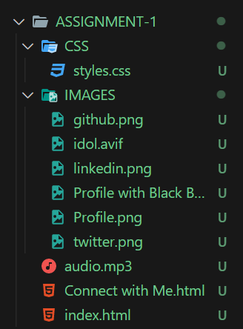

**Head Section**

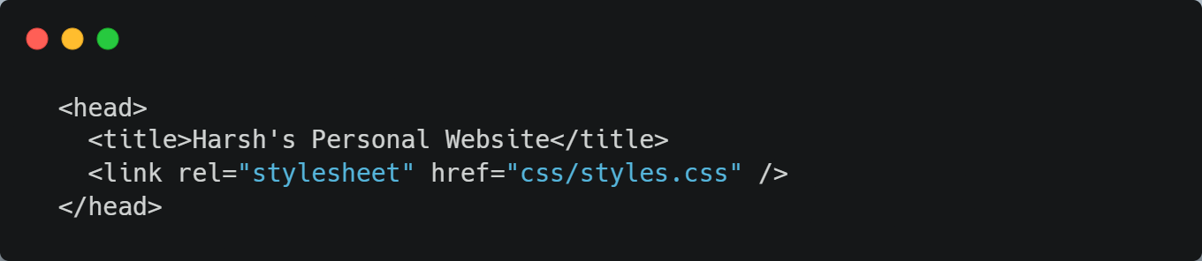

**Body Section – Main profile**

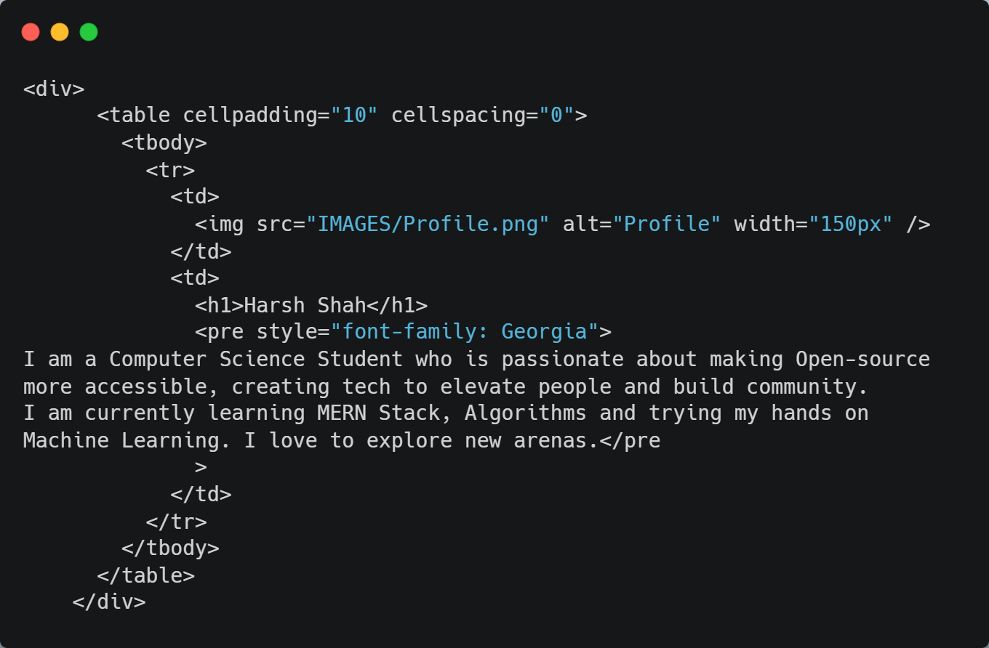



**Body Section – Education Details**

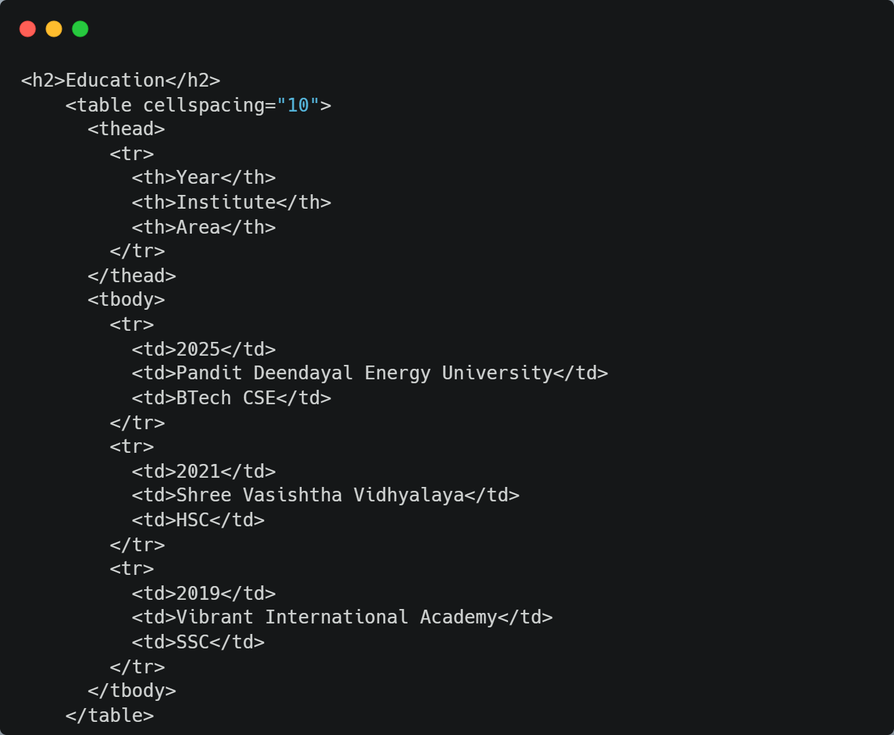



**Body - Skills Section**

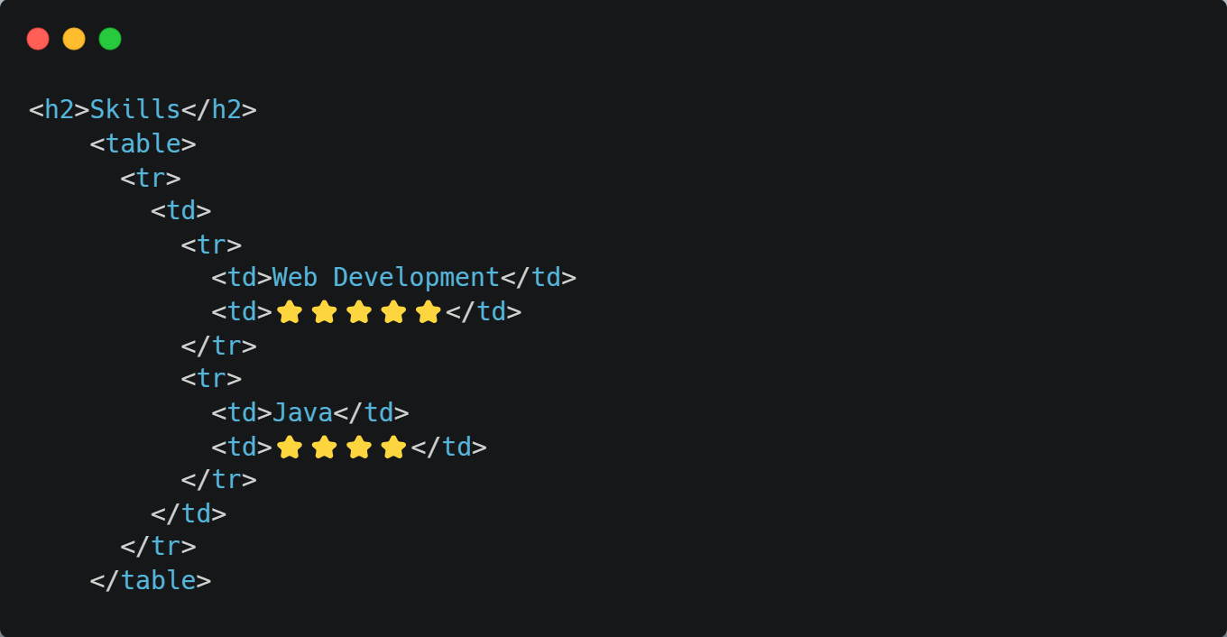



**Body – Hobbies**

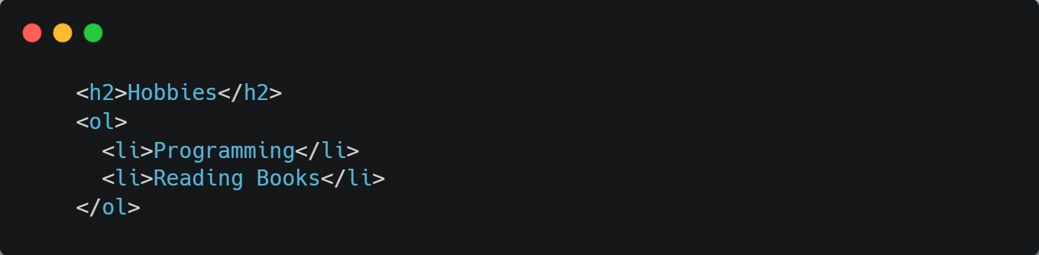

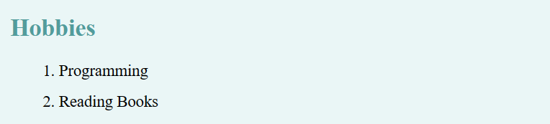

**Body - Favourites**

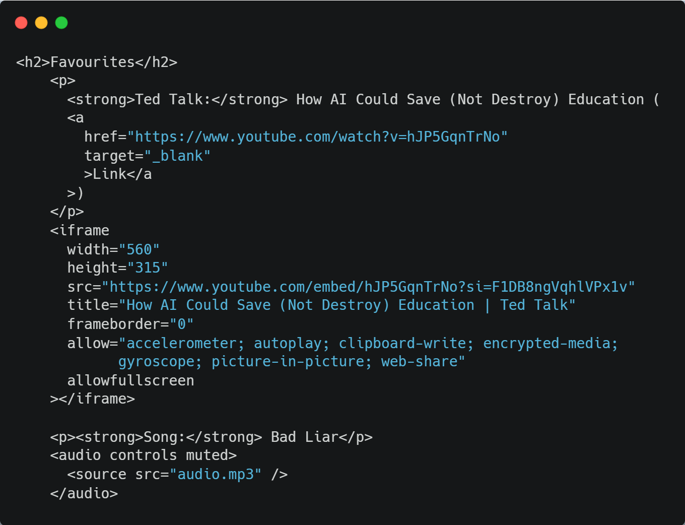



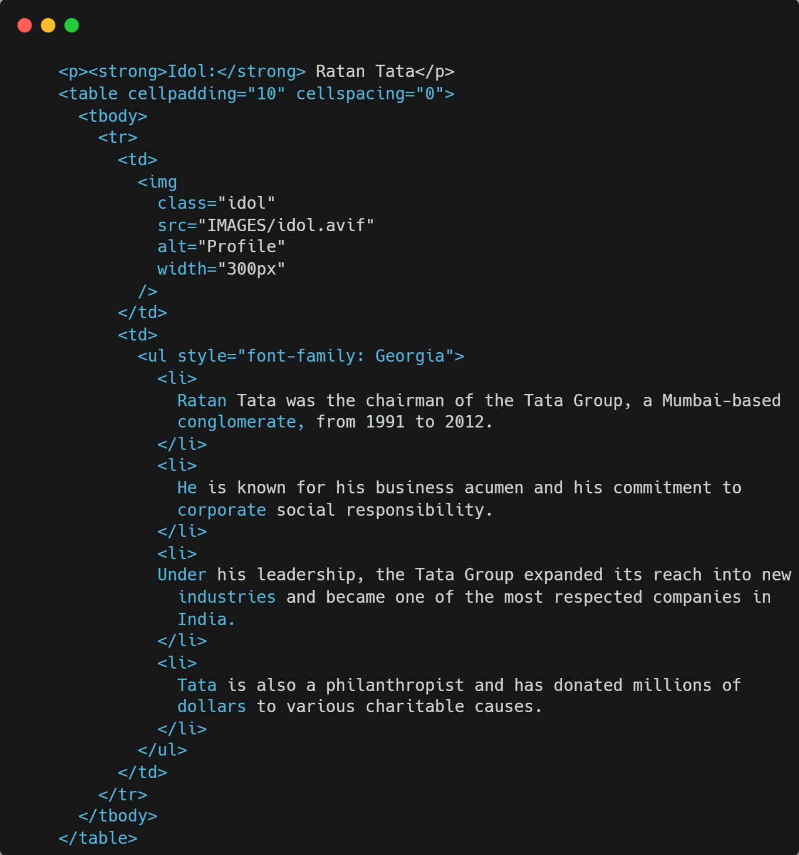

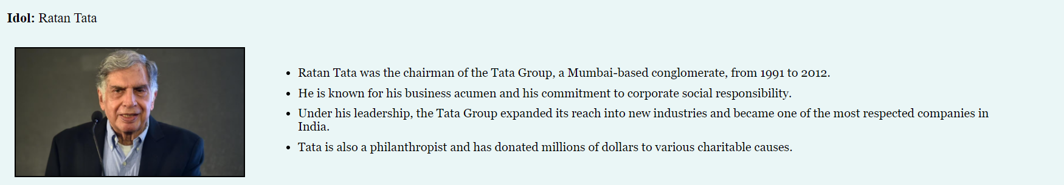

**Body – Network Page (Redirection to another page)**

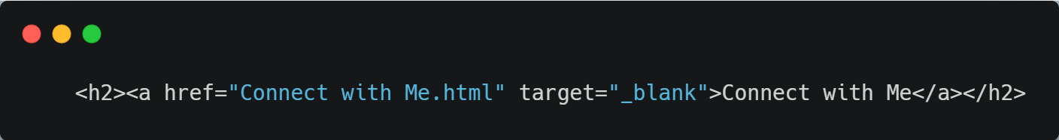



**Connect with Me Page (Page 2)**

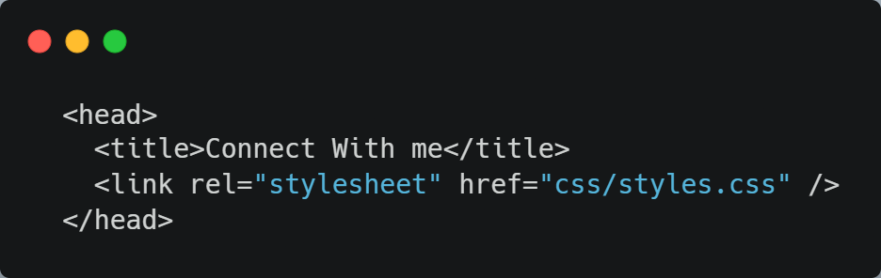

**Body – Social Profiles**

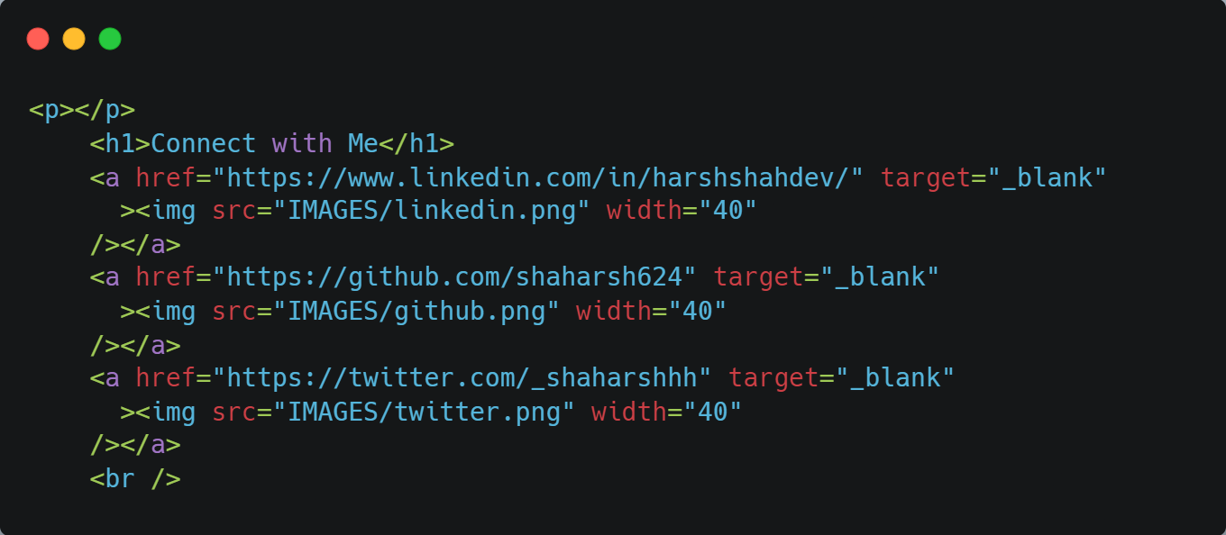

**Body – Contact Details**

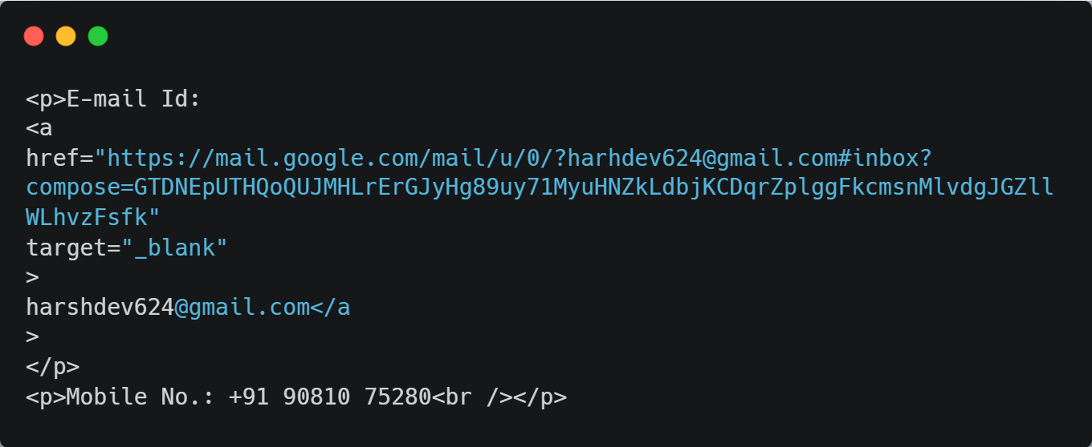

**Body – Contact Form**

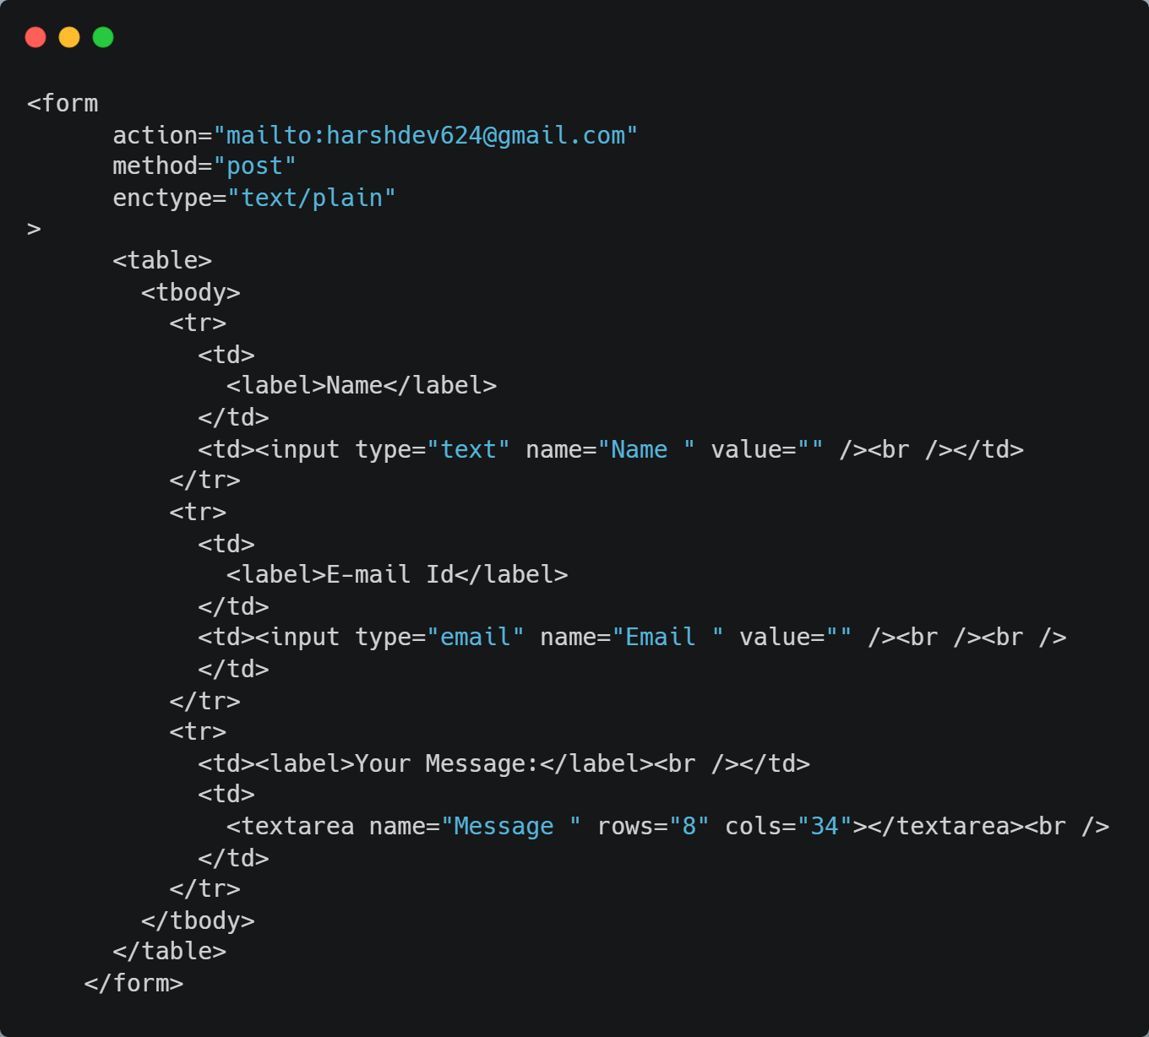



**CSS Styles**

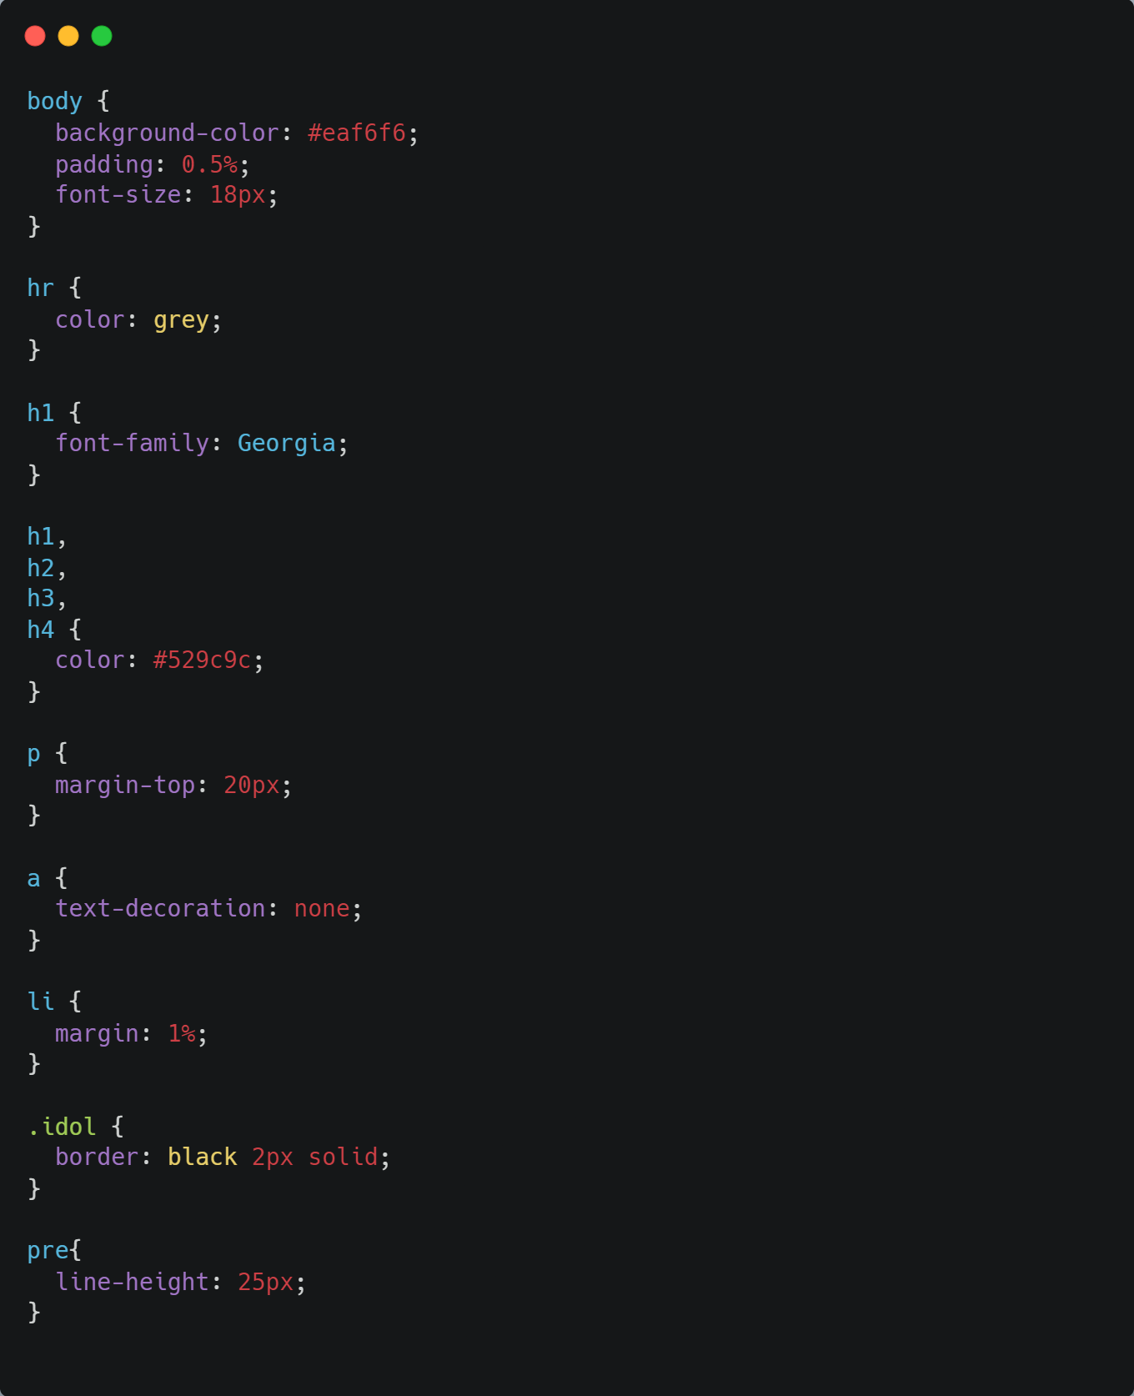



**Conclusion/Inference**

**References**